# Where To Download VM

## Linux Images

From my own experience, images provided by **this site is stable**. It provides both minimal version (only command line) and graphic version for each image. Make sure to **follow the guideline** for opening the VM images on the site.

* Download images: <https://www.linuxvmimages.com/> (note: From my exp, VB images have lots of error)
* Get image passwords: <https://www.linuxvmimages.com/how-to-use/vm-image-password/>

## Windows Images

# VMWare Workstation vs. VirtualBox

For a complete VMWare Workstation vs. VirtualBox comparison and **many helpful feature explanations** about virtual machines, check <https://www.nakivo.com/blog/vmware-vs-virtual-box-comprehensive-comparison/>.

**From my own experience, VMWare Workstation is way better than VirtualBox**.

I struggled with following issues when working on VirtualBox:

* After rebooting, keyboard is not captured on VirtualBox (although all settings are unchanged).
* After rebooting, cannot access the Internet (although all settings are unchanged).
* Sometimes cannot copy/paste clipboard between host and VM (although enabled copy/paste setting and install Guest Additions).
* Sometimes cannot copy/paste files between host and VM (although enabled drag and drop setting and install Guest Additions).
* Sometimes get error "failed to fetch …" when downloading packages (cannot understand why but I got this issue on both Ubuntu and CentOS. After that, I switched to VMWare and the error was gone. So I guess the VirtualBox is the cause – maybe network connection or server is the root cause, but I still cannot fix it).
* Package gnome-shell-extensions failed to install. Cause auto logging out when using. Very very frustrating!

# VMWare

## Notes When Installing VMWare Workstation

### Installing Windows Hypervisor Platform (WHP)

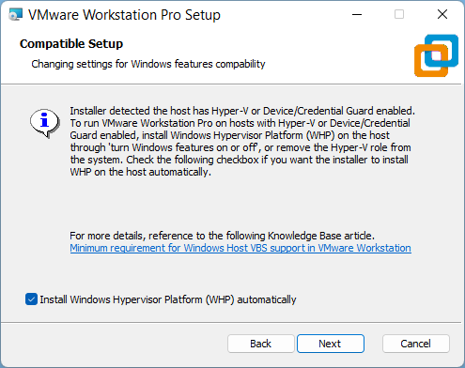

## Importing VM Image

### OVF File

More [details](https://www.linuxvmimages.com/how-to-use/how-to-import-vm-images-in-vmware/).

### VMX File

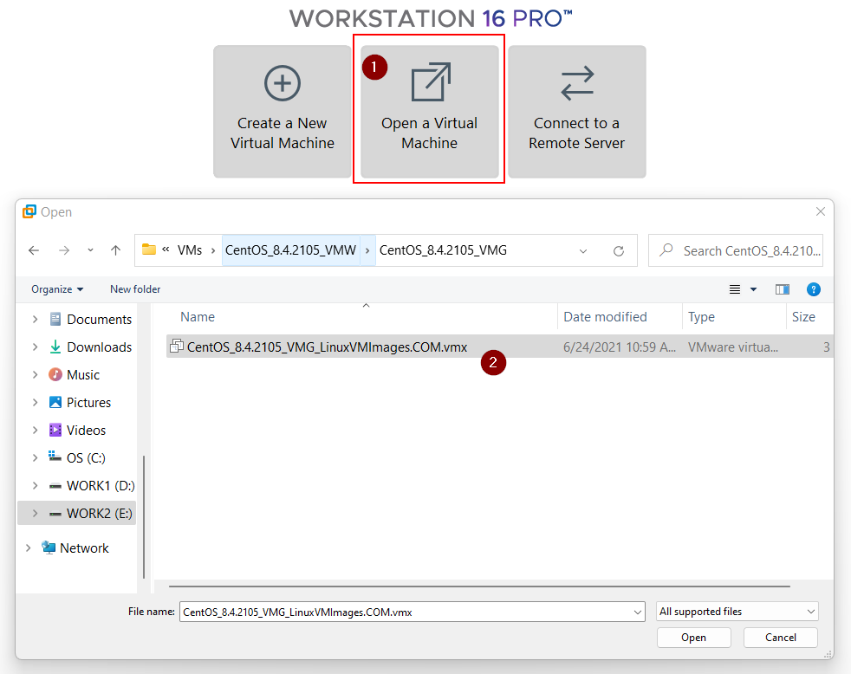

More [details](https://www.linuxvmimages.com/how-to-use/how-to-import-vm-images-in-vmware-vmdk/).

### ISO File

More [details](https://linuxhint.com/install_ubuntu_vmware_workstation/).

## Shared Folder and Other Advanced Features

Following steps:

1. Install *VMWare Tools* (from VMWare Workstation > VMWare Tools Installation > follow the guide).
2. Shutdown guest.
3. Enable Shared Folder. Then create a new shared folder, for example:

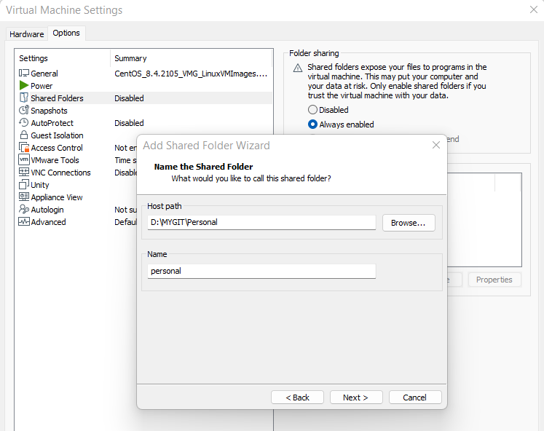

Also, enable other advanced features (**Drag'n'Drop**, **Shared Clipboard**, **Guest Resolution Fit**) from VMWare's settings.

1. Start guest.
2. Mount the shared folder with command:

# Mounts all shares to <abs-path-to-shared-folder-on-guest>

$ /usr/bin/vmhgfs-fuse .host:/ <abs-path-to-shared-folder-on-guest> -o subtype=vmhgfs-fuse,allow_other

Or

# Mounts the share named <abs-path-to-shared-folder-on-host> to <abs-path-to-shared-folder-on-guest>

$ /usr/bin/vmhgfs-fuse .host:/<shared-folder-name-on-host> <abs-path-to-shared-folder-on-guest> -o subtype=vmhgfs-fuse,allow_other

For example:

$ /usr/bin/vmhgfs-fuse .host:/personal ~/SharedFolder -o subtype=vmhgfs-fuse,allow_other

**Refs:**

<https://docs.vmware.com/en/VMware-Workstation-Player-for-Windows/15.0/com.vmware.player.win.using.doc/GUID-0C23FCBF-F0CC-447B-A08E-35B90C52091E.html>

**Warnings:**

VMWare does not support symbolic links for Window host – Linux guest in shared-folder mode.

The attempt to create symbolic links in shared-folder mode will lead to this error: "*ln: failed to create symbolic link … Operation not supported.*" Details [here](https://discourse.pro/t/topic/256/2).

For Linus host – Windows guest, VMWare supports a [way](https://kb.vmware.com/s/article/1007277) to fix this error.

## Running Guest on Background

Click the Close (x) button from VMWare Workstation, then choose "Run in Background":

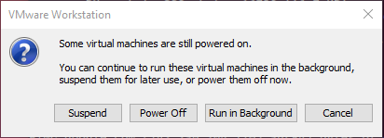

## Adjusting Display Resolution

From CMD (with Administrator permission), run:

"C:\Program Files\VMware\VMware Tools\VMwareResolutionSet.exe" 0 1 , 0 0 2024 1060

Note: "2024" and "1060" are display width and height, respectively. Change them based on your demand.

## Snapshot

# VirtualBox

## Importing VM Image

### Vbox File

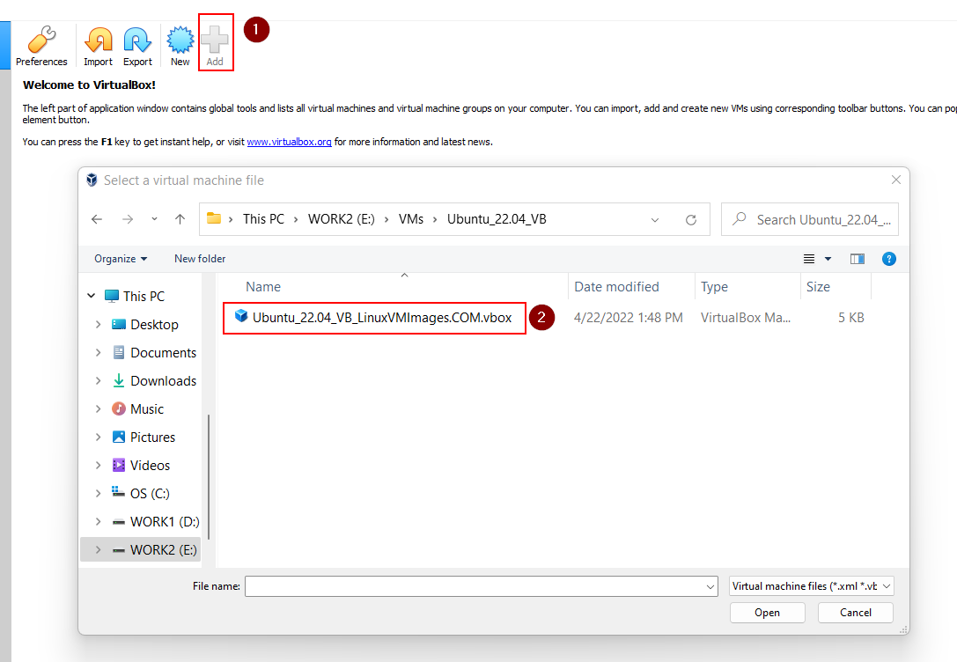

More [details](https://www.linuxvmimages.com/how-to-use/how-to-import-vm-images-in-virtualbox-vdi/).

### OVA File

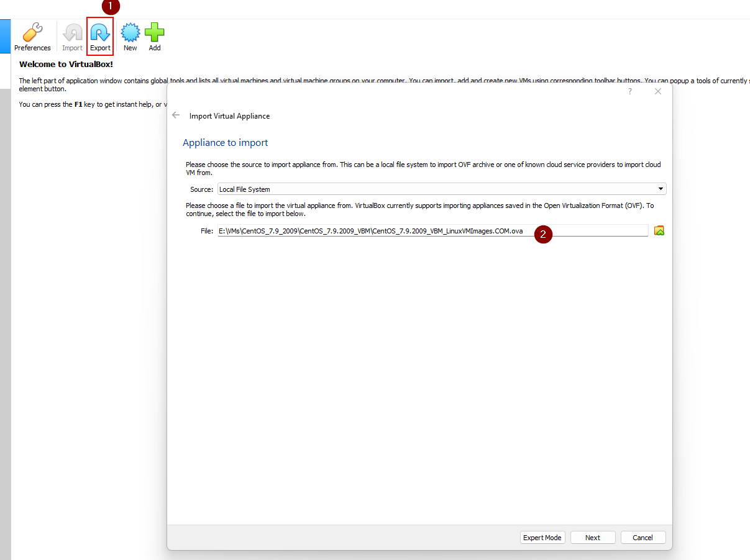

More [details](https://www.linuxvmimages.com/how-to-use/how-to-import-vm-images-in-virtualbox/).

## Shared Folder and Other Advanced Features

Following steps:

1. Install *VB Guest Additions*: <https://www.tecmint.com/install-virtualbox-guest-additions-in-centos-rhel-fedora/>
2. Shutdown guest.
3. Enable Shared Folder. Then create a new shared folder, for example:

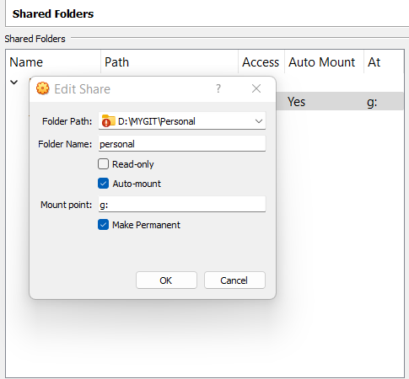

Note:

* In the "Mount point" field, specify the drive letter to map the folder as a drive on the virtual machine.
* Check the "Make Permanent" option to keep the shared folder mounted even after restarting the virtual machine.

Also, enable other advanced features (**Drag'n'Drop**, **Shared Clipboard**, **Guest Resolution Fit**) from VB's settings (Settings > General > Advanced).

1. Start guest.
2. Mount the shared folder with command:

$ sudo mount -o uid=1000,gid=1000 -t vboxsf <shared-folder-name-on-host>

<abs-path-to-shared-folder-on-guest>

For example:

$ sudo mount -o uid=1000,gid=1000 -t vboxsf personal ~/SharedFolder

## Snapshot

## Ubuntu on VirtualBox

Speed up Ubuntu on VirtualBox: <https://www.linuxbabe.com/virtualbox/speed-up-ubuntu-virtualbox> (Ubuntu running on VirtualBox is very slow, compared to other Linux distributions).

# Network

## Bridged vs. NAT vs. Host Only

<https://communities.vmware.com/t5/VMware-Workstation-Player/accessing-laptop-s-wifi-hardware/td-p/2548083>

## Adding Network Adapter

In most cases, network adapter (either wired or wireless) is added by default when we download the VM image. However, if it's not added (of course, we cannot access the Internet), we have to do that manually.

**How to know if a network adapter is not added?**

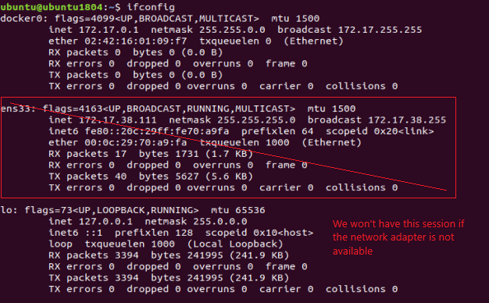

**Note**: The device is named 'ens33' in this example, but the naming rule is actually 'ens***'. So, it can be a different number.

**How to add a network adapter via Network Manager CLI?**

$ mcli d

$ sudo ip link set dev ens33 up

# It might not be "ens33", so pick the right one from the first cmd

$ sudo dhclient -v ens33

**Note:** Above way, if the Bridge doesn't work, try with the NAT.

**Refs**:

<https://unix.stackexchange.com/a/560951>

<https://unix.stackexchange.com/a/525842>

## Using Wi-Fi in VMs

You CANNOT find your wireless adapter within the virtual machine. It doesn't see your real hardware but only "virtual hardware" provided by the virtualization product. Detailed explanation [here](https://askubuntu.com/a/1212985).

So, if you want to have Wi-Fi in your VMWare guest, you must follow one of these approaches:

1. Provide your own Wi-Fi network adapter in the form of a **USB Wi-Fi network adapter**.
2. Some say "Use an automatic **Bridged** connection. This will directly connect to your computers physical network".

Some say "Wireless connections cannot be bridged". Detailed explanation [here](https://superuser.com/a/1114171).

NOTE: I tried Bridge, and it WORKS.

1. Configure NAT network settings, such as [this video](https://www.youtube.com/watch?v=bdPa4kBN72I&ab_channel=AnoopRana).

# SSH Between Host and VM Guest

## Between Local Host and Local VM Guest

Running virtual machines with an UI can significantly slow down the whole computer. A simple yet effective solution is to command the VM via SSH, while letting the VM runs on background.

Following below steps:

1. Get IP address of the Linux guest with ifconfig command.

2. Verify the guest's IP address to make sure it can be accessed from the host:

ping <guest-ip>

3. Connect to the guest via SSH:

ssh [guest-user@]guest-ip[:port]]

This confirmation only shows up for the first time accessing guest from Windows host.

Example:

C:\Users\triho>ssh centos@192.168.86.129

The authenticity of host '192.168.86.129 (192.168.86.129)' can't be established.

ECDSA key fingerprint is SHA256:f63GDTlNka9UzwsdXcS5xoN24E3/27lzvZ2Qj/ioFR4.

Are you sure you want to continue connecting (yes/no)? yes

Warning: Permanently added '192.168.86.129' (ECDSA) to the list of known hosts.

+-+-+-+-+-+-+-+-+-+-+-+-+-++-+-+-+-+-+-+-+-+-+-+-+-+-+-+-+-+-++-+-+-+

L I N U X V M I M A G E S . C O M

+-+-+-+-+-+-+-+-+-+-+-+-+-+-+-+-+-+-+-+-+-+-+-+-+-+-+-+-+-+-+-+-+-+-+

User Name: centos

Password: centos (sudo su -)

centos@192.168.86.129's password:

Last login: Sun Sep 13 11:36:33 2020 from 192.168.86.1

+-+-+-+-+-+-+-+-+-+-+-+-+-++-+-+-+-+-+-+-+-+-+-+-+-+-+-+-+-+-++-+-+-+

L I N U X V M I M A G E S . C O M

+-+-+-+-+-+-+-+-+-+-+-+-+-+-+-+-+-+-+-+-+-+-+-+-+-+-+-+-+-+-+-+-+-+-+

User Name: centos

Password: centos (sudo su -)

[centos@centos7 ~]$

[centos@centos7 ~]$ ls

Desktop Documents Downloads Music Pictures Public Templates Videos

[centos@centos7 ~]$ exit

logout

Connection to 192.168.86.129 closed.

### Tips:

* VMWare provides "one-click SSH" feature:

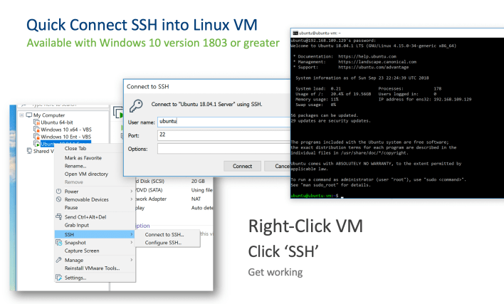

## Between Local Host and Remote VM Guest

What if the VM is running on another computer, and you still want to command it from your computer?

In this example, we'll connect from a Windows host to a Linux guest which run on VMWare Player / Virtual Box on another computer via SSH.

Note: We'll use NAT network instead of Bridge.

### VMWare

**1. Modify NAT config**

Open and edit C:\ProgramData\VMware\vmnetnat.conf with Administrator permission as followings:

In [incomingtcp] section, add a line:

2244 = <vm-guest-linux-ip>:22

Note: Besides port 2244, you can choose any port you want.

After saving the file, run Windows command to restart VMWare NAT service (so the config can be reloaded) by running following commands:

$ net stop "VMWare NAT Service"

$ net start "VMWare NAT Service"

Note: If these commands won't work, you can restart the service with *Services* app on Windows.

To make sure things work, try SSH into your Linux guest from your Windows host (though it's not our purpose) with the command:

$ ssh -p 2244 <linux-username>@localhost

**2. Modify Windows Firewall config**

Trying to SSH to the guest from another host won't be allowed because of the Windows Firewall rules.

To make it possible, you have two ways:

1. Disable Windows Firewall
2. Add new rule by:

Open Control Panel > Windows Defender Firewall > Advanced settings. New an 'Inbound Rules'.

Select 'Port' as rule type.

Select TCP and set the port '2244'

Save

**3. SSH to your Linux VM guest from remote Windows host**

Simply run this command:

$ ssh -p 2244 <linux-username>@<windows-hostname-or-ip>

Note: windows-hostname-or-ip is of the local Windows host which the virtual machine run on, NOT of the remote host we're typing on.

### VirtualBox

**1. Modify NAT config**

From VirtualBox's Settings > Network > Adapter[n] > Advanced, click 'Port Forwarding'. Configure a NAT rule, for instance:

* Name: External SSH incoming
* protocol: TCP
* Host IP: Your Windows host public IP
* Host port: The port the remote SSH connects to (e.g., port 2244)
* Guest IP: Your virtual machine Linux guest IP
* Guest port: it’s TCP 22 for SSH

**2. SSH to your Linux VM guest from another Windows host**

Simply run this command:

$ ssh -p 2244 <linux-username>@<windows-hostname-or-ip>

Note: windows-hostname-or-ip is of the local Windows host which the virtual machine run on, NOT of the remote host we're typing on.

Ref: <https://slmeng.medium.com/how-to-ssh-into-vmware-player-virtual-box-guest-linux-os-remotely-host-os-is-window-10-40cb348c996f>